Project Proposal
(at most two-pages, 11-point font, single spacing, 1 inch margins)
- Title of the Project : Heatmap to identify the foot fall pattern in retail stores
- Brief on the project:
Background: We have so many tools to measure the online retailing which we call as digital analytics; however we have limited visibility regarding offline marketing. With the advancement and penetration of big offline stores and supermarket like Argos and big bazaar, it’s imperative to have a media via we should be able to measure the various aspects of Offline retail.

Intent: Through this project we would like to measure certain aspects of Offline marketing that would cover (but not limited to):
- Measure the effectiveness of Direct marketing - display videos, brochures, ad-posters banners etc..
- Optimum place for the direct promotional effort
- Measuring densely trafficked store / supermarket area
- Effective product positioning / placement
- Staffing Plan
- ROI for a particular event

Approach: Our approach is to collect the outdoor CCTV footage of a supermarket and then break the entire video footage to static jpg images. We will be using python to decipher each image to identify their pixel coordinates along with their underlying color codes.
RGB Color: We think that RGB color of an individual pixel is relevant feature to measure coordinates. For the static coordinates, we would measure the optimum RGB colors via regression over python / R tool.

Deliverables of the project:
- Heatmap Entire dataset is then converted to Heatmap that would allow us to determine where visitor stop and measure linger time in areas of interest.
- Optimum place in store where we have a dense heatmap pattern

- Resources :
- Store CCTV Footage
- Tools: Spark , Python and R

- Team Members: Priyanka Ramane, Jyoti Sahay, Chinmay Palkar

- Milestones with timeline
Milestones | Start date | Finish date | Grading Grading
- Define a problem | 1-June-2016 | 8-June-2016 | 5%
- Get the Data | 8-June-2016 | 20-June-2016 | 5%
- Explore and pre-process data | 20-June-2016 | 25-June-2016 | 10%
- Create Features | 25-June-2016 | 5-July-2016 | 5%
- Create Models (classification models on train=features from gpslocation,age,ethnicity,race,sex, number of cases of the disease,probability_only_on_location,probability only on age, probability_only_on_sex,probability only on number of cases,facebook likes,news articles shared by a user on facebook (after giving the fb login access on our app) test= on age,ethnicity,race,sex to classify individual probabilities ki range..Vinay wants students to execute step by step and I can teach relevant packages.Guys, WNS global recommendation of placement is what I am aiming for you all even if this venture fails ,but it will not fail as vinay knows markonian models and lot of things in depth even after selling Marketics(marketing analytics) in 360 crores to WNS global in 2007 !!! ).  Mine and his latest knowledge of last 3 years will not make this venture a failure. Do let me know if you are ok to do step by step approach with us. | 5-July-2016 | 20-July-2016 | 55%
- Deploy & consume model | 20th July |  | 20%
- Report Writing |  |  | 10%
- Project submission |  |  | 15%
- Final presentation with project/ product demonstration |  |  | 20%
- Blog publishing (this will not be done within this nda) |  | 30th Aug | 5%
*Refer Data Science Process Doc – if deadline is missed no weightage will be given and it will entail loss of grade for the group. All milestones should be submitted online as per date indicated by the group.

- Technical architecture


Python
Video Footage Jpg burst Image Pixels and co-ordinates

Regression – To find the best fitted pixels DB creation
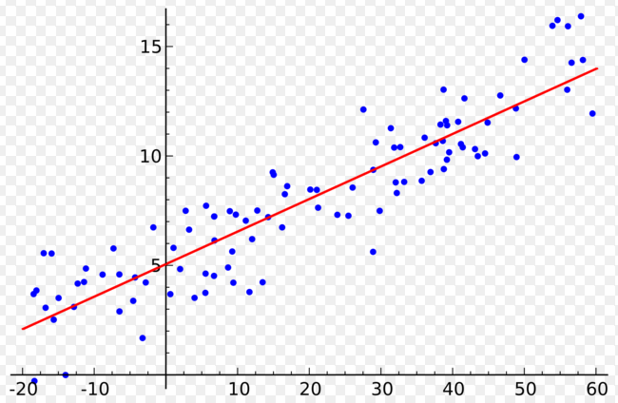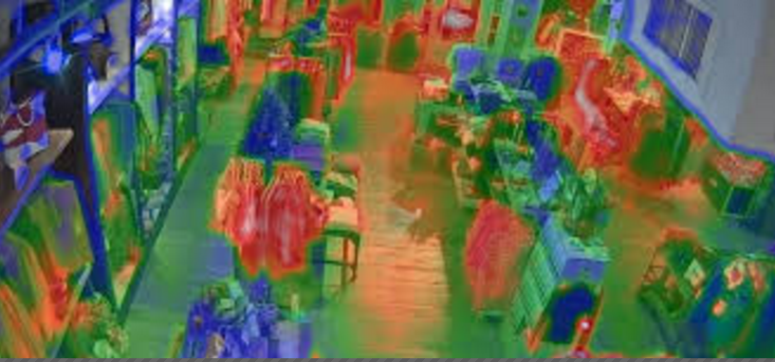
SPARK
HEAT MAP GENERATION

